# USE CASES

**User Story**

As a user, I want to be able to see the general sentiment on Reddit for a given time period for Bitcoin.

**Requirements**

Database/table storage. Reddit bot (Access to Reddit API). Script for Reddit bot.

|  |  |
| --- | --- |
| *Use case name* | Search Reddit data |
| *Participating actors* | User, Database, Reddit API, Reddit Bot Script |
| *Flow of events:  Normal flow* | 1. User navigates to Social Media Page 2. User chooses a date 3. User Clicks Search button 4. Website makes HTTP request to trigger script 5. Script calls Reddit API and gets data which it sends back to the website 6. Website Displays data on chart |
| *Pre-condition* | User is logged in |
| *Post-condition* | User can see Reddit data |

**Use Case Scenario**

**Use Case Diagram**

**Sequence Diagram**

**User Story**

As a user, I want to be able to view live updates on Twitter activity and general sentiment for Bitcoin.

**Requirements**

Database/Table storage. Twitter bot (Access to Twitter API). Application for Twitter bot.

**Use Case Scenario**

|  |  |
| --- | --- |
| *Use case name* | View Twitter Feed |
| *Participating actors* | User, Database, Twitter API, Twitter Bot application |
| *Flow of events:  Normal flow* | 1. User navigates to Social Media Page 2. Website Displays Twitter feed to user |
| *Pre-condition* | User is logged in |
| *Post-condition* | User can see Twitter timeline |

**Use Case Diagram**

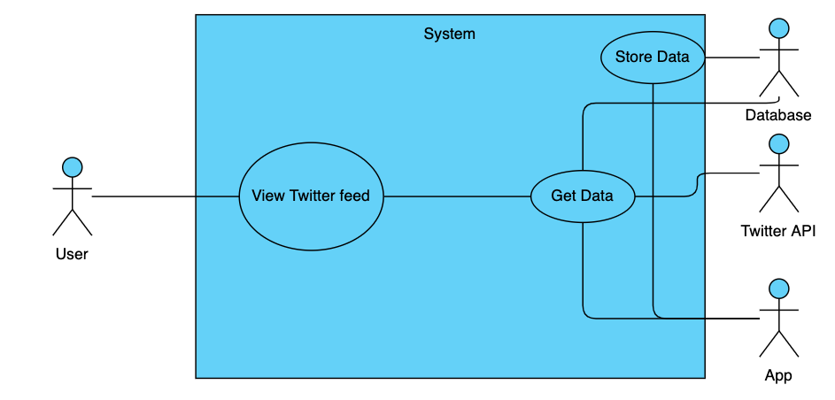

**Sequence Diagram**